- Create user with name Techie and provide sudo access to user. (Created user name Techie-03 and to change user used ( su – techie-03) (sudo access – login first to su – vboxuser which is root user then gave permission with cm – sudo usermod -aG sudo techie-03)
- Navigate to the home directory. ( CM – cd ~ :- use to home directory)
- Create a new directory. (Cm – mkdir :- created cd-techie)
- List the contents of a directory. (CM – ls)
- Change the current directory. (CM – cd :- use for current directory change)
- Create a new empty file. ( CM – Touch techie.txt created file)
- View the contents of a file. ( CM – cat techie.txt :- Hello Wasif )
- Copy a file to another location. ( CM – cp techie.txt /home/techie-03)
- Move a file to another location. ( CM – mv techie.txt //home/techie-03)
- Rename a file. ( CM – mv – old file name - Was03 new file name Was06) Note created new file name was03 and rename was06
- Delete a file. ( Cm . rm Was06)
- Grant or revoke permissions on a file or directory. Cm – chmod ( user- 4,group – 2,others -1) gave permission for both directory and file ex:- 761 and 774)
- View the current date and time. (Cm :- date )
- Check the system uptime. (Cm – uptime)
- View the running processes. ( Cm – Top )
- Kill a running process. ( Cm – kill -9 and process id )
- Install a package using the package manager (e.g., apt or yum). (ubuntu – sudo apt install nginx)
- Update the system packages. ( Cm – sudo apt update or sudo apt upgrade)
- Create a symbolic link. (Cm - ln -s – target-file (techie.txt) or directory) (link name(ngnix)) to check ls -l (lrwrwxrwx) file deatils
- Search for files using the find command. (Cm – find and (file name)techie.txt)
- Compress and decompress files using tar. (Cm – tar cvf compress file name ( tar.cd-techie file to which compress (cd-techie)) and for (decompress tar xvf tar.cd-techie)
- Monitor system resources with top or htop. (Cm – top monitor system resources)
- Create and manage user groups. Cm – ( sudo groupadd group-name( Group-user) and added with Cm- sudo usermod -aG (group-name (Group-user) user-name( Techie-03) to check (Cm- id user or group user)
- Set up SSH password less authentication. ( Cm- passwd type old passwd then two time new password)
- Monitor log files using tail or grep. (Cm- Tail-3 and file-name to check starting 3 lines and also head -4 file name to check last 4 line, grep letter N or Z and file name to check particular word in line. )
- Set up a web server (e.g., Apache or Nginx). (Cm - Sudo apt install nginx or apache2)
- Configure and secure a MySQL Database. 1. Sudo apt update 2. Sudo apt install mysql-server- y 3. Sudo systemctl start mysql 4 sudo systemctl staus mysql. Create databases name – devopsdb then show databases
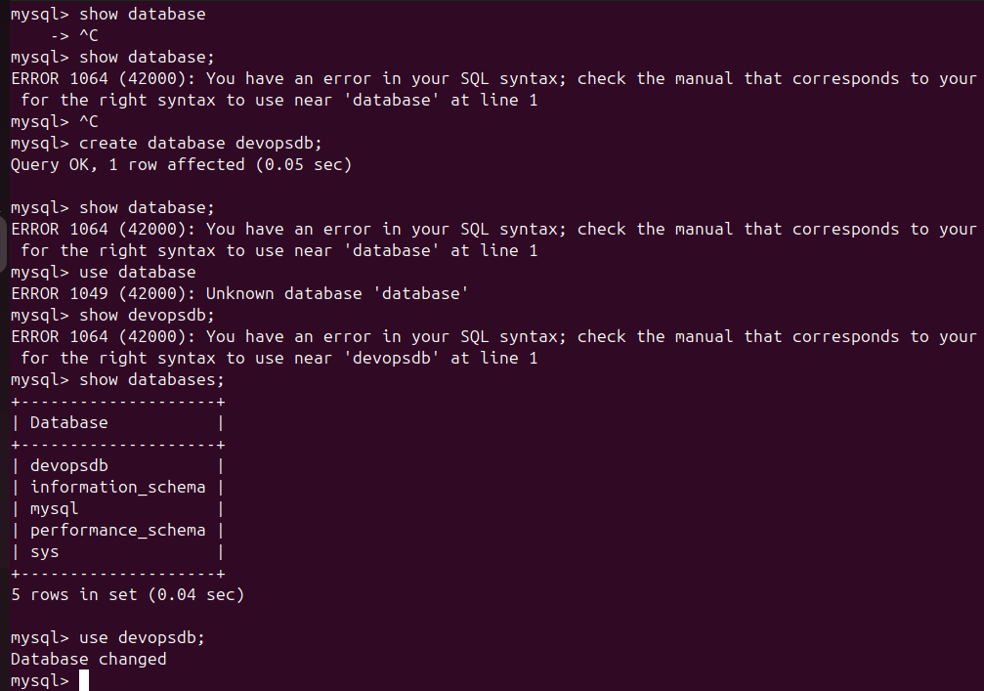
- Set up a Application Server (e.g.,Apache Tomcat)
install java ( apt install default-jdk) then install tomcat for ubuntu ( tomcat official site and copy link( wget past link and hit enter) after that untar comcat file by tar xvf name file then rename tomcat ( mv old name new name )then cd go to directory of comcat cd again go to bin then start file ( ./startup.sh)
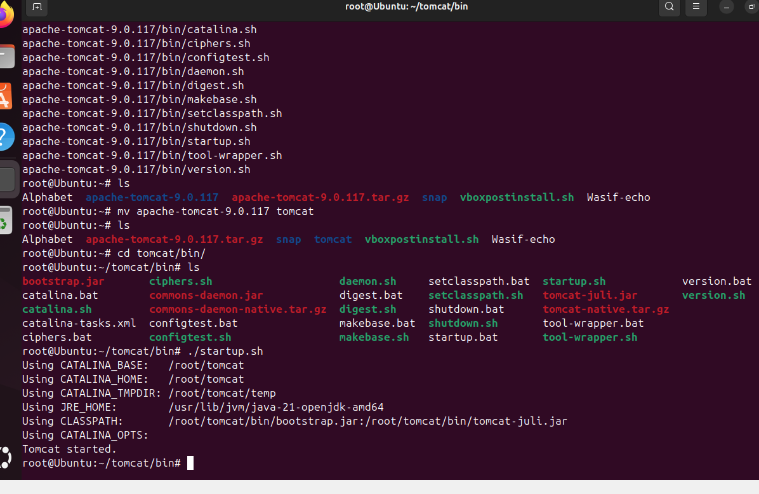
create a service file for Apache Tomcat.(Should execute by using systemtctl command) steps: download any sample war file check file by cd and cd webapps and wget sample file for tomcat then shutdown and start up cm -./shutdown.sh ./startup.sh
run on local host by typing localhost:8080/sample ,If you want to change html file open nano editor make a change (Wasif ) and save it ctr+y+enter key to save nano 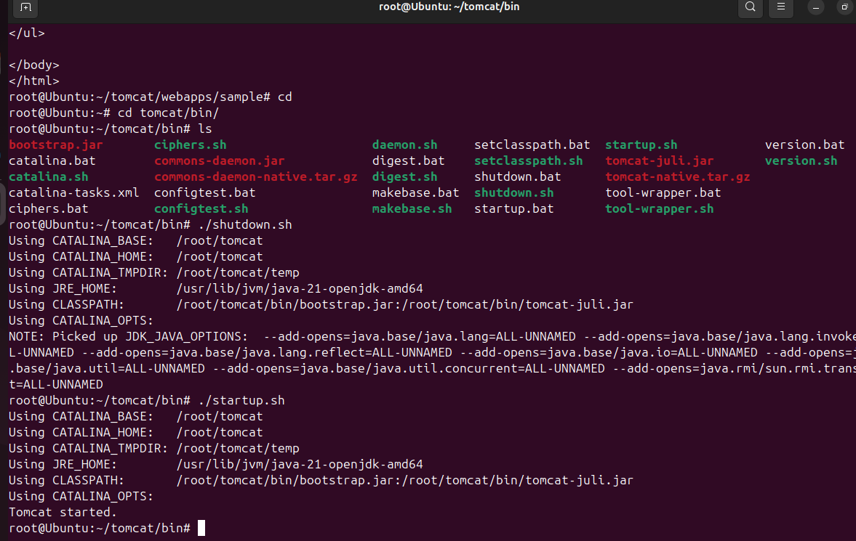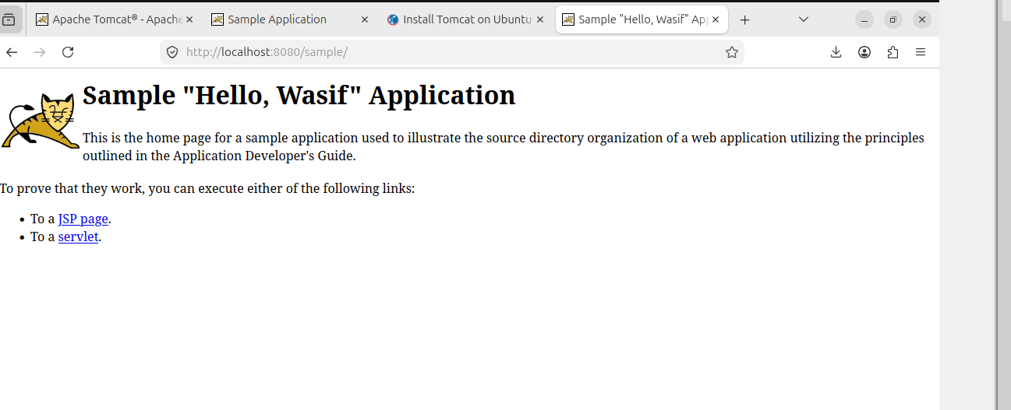
Print specific columns from a delimited file.
101:John:5000:Hyderabad
102:Ali:6000:Delhi
103:Rahul:5500:Mumbai
To print only Name and City columns:
cut -d ':' -f 2,4 data.txt
Output:
- John:Hyderabad
Ali:Delhi
Rahul:Mumbai
- 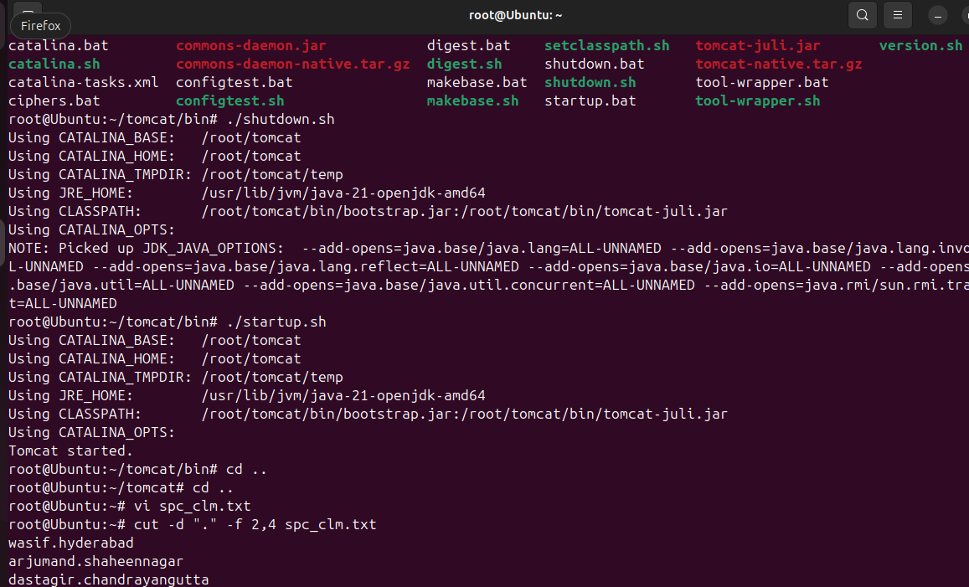
- Filter and print lines based on a specific pattern or condition.
awk NR==2 file name for printing line no 2
Grep “wasif” file name to print line which contains wasif
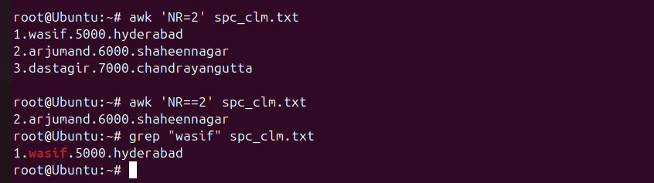
- Calculate and print the average, sum, or other statistics of a column.
used awk command and formula for sum, average statistics file
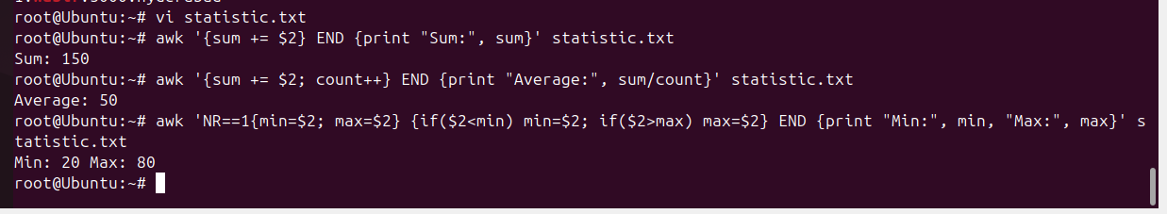
- Perform string manipulation, such as extracting substrings or changing case.
( cm – echo “$(text:5)
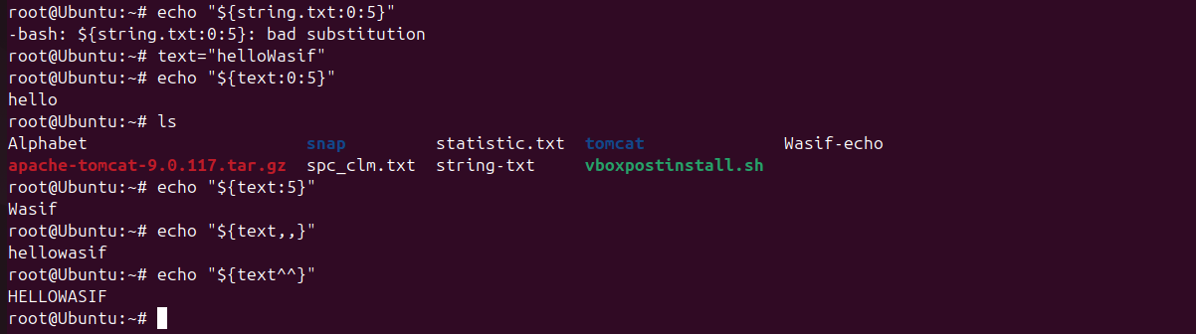
- Count the occurrences of a specific pattern in a file.
grep “apple” file name | wc -l
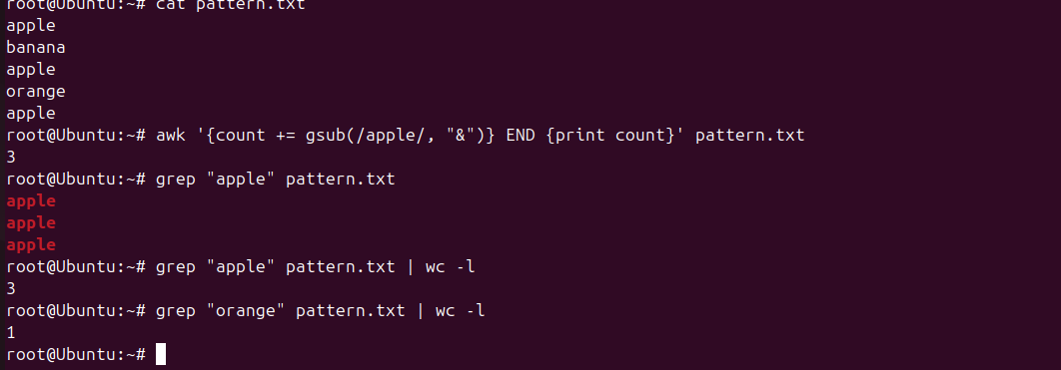
- Sort lines based on a specific field or column.
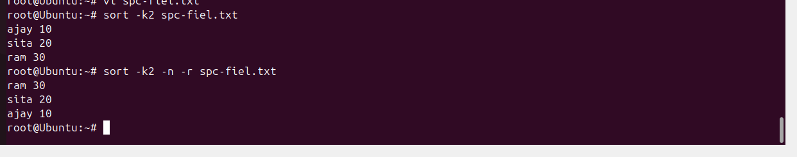
- Merge multiple files based on a common field or column.
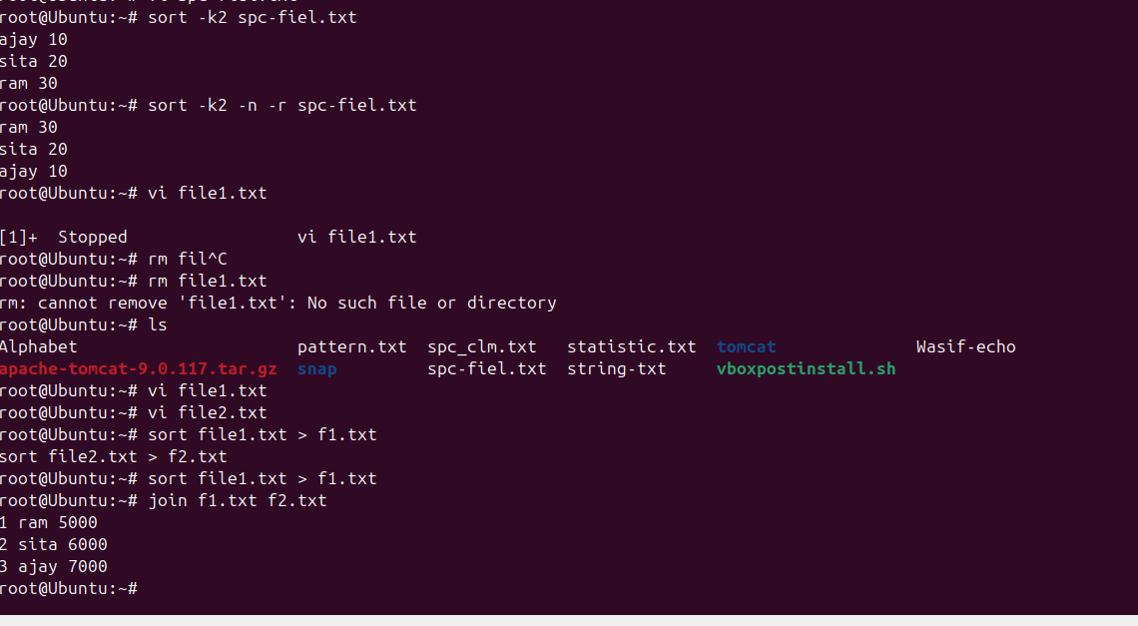
- Substitute text in a file using search and replace.

- Delete specific lines based on a pattern or line number.
- Append or insert text before or after a specific pattern or line.
- Print only specific lines from a file.
41 Copy file from linux to windows machine
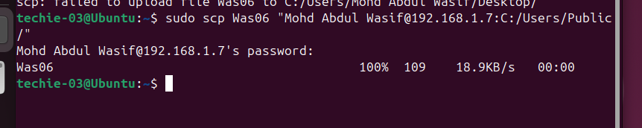

- 5 use cases for AWK and 5 use cases for sed

